Frame Profiles
Collection of profiles used to install machine vision systems in customer applications

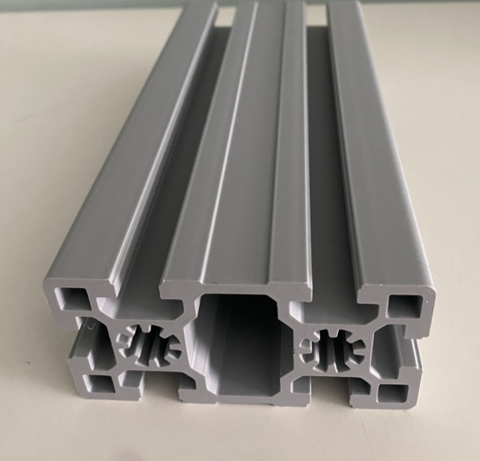

Project Goals
The idea is to collect the most used profiles and print in a 200 mm chunk to simulate how they work with different T Bolts, Brackets and so on.

Reference

Europe
This is the main model for Europe:
- SAETTONE 45X90mm, 8 mm slot suitable for T-Nuts
https://store.boschrexroth.com/Tecnica-di-montaggio/Elementi-meccanici-di-base/Profilati-e-accessori/Profilo/PROFILATO-SAETTONE_3842553615?cclcl=it_IT
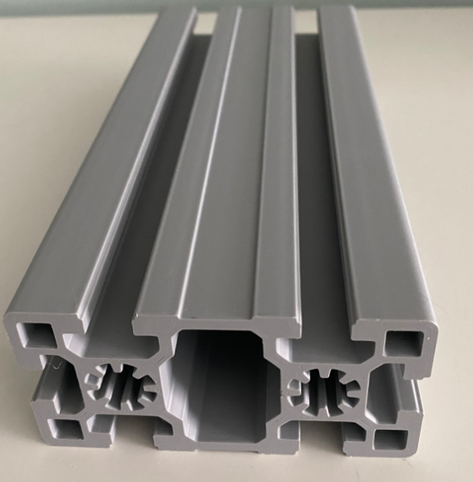

This one is used for small length because 30x60 is small:
- SAETTONE 30X60mm, 8 mm slot suitable for T-Nuts https://store.boschrexroth.com/Tecnica-di-montaggio/Elementi-meccanici-di-base/Profilati-e-accessori/Profilo/PROFILATO-SAETTONE_3842557205?cclcl=it_IT

North America
Company: 8020
1.50” X 3.00” T-Slotted Profile - Six Open T-Slots
1.50" = 38.1 mm
3.00" = 76.2 mm
https://8020.net/1530.html?srsltid=AfmBOop8W_vTOVW1h4lAdLmrN0CuxOTNk4sc8Fv9JRuaqty6O4VWT53R

This is for North America
Company: RoboUnits
https://robotunits.com/en-us/shop/extrusion-fastening-technology/extrusion-technology-40mm-series/extrusion-40x80/

